How to Set Up For Success with Online Workout Streaming Through Zoom & Facebook

What you will need:
- Zoom account (paid if you plan to hold a zoom call for longer than 40 minutes or with more than 100 participants including you)
- Laptop with a good built in or an external camera
- Cell phone/tablet with a good quality front facing camera will work in place of the laptop (see pros and cons)
- Decent internet Connection
- Additional lighting if at home
- Lav mic or headset
- Phone/Tablet stand or tripod
- Stable surface at least 8ft from where you will stand
- Timer if applicable
- Shareable music playlist

Ahead of time, practice! Some basic tips:
Practice your live stream to a dummy Facebook group (see instructions below)
Check your camera angle, listen to the audio - is it clear?
Use hand gestures when teaching
Be prepared to work and talk at the same time and practice talking into your mic without heavy breathing like a saucy phone call!
Practice looking at your screen for watching client form (if necessary) while you train
Be prepared to count your reps and tempo or use your timer. Set your timer in advance and practice using it. I use the Gymboss minimax
Watch your screen for questions/feedback
Create a video or live stream to your members to explain how to download zoom, provide them with the link. You can share your screen to do this (see instructions in this guide). Show your members what zoom training will look like by having them join your live zoom call while you stream to Facebook.
Create a playlist for your class and share it ahead of time with your members. Spotify and Pandora are perfect for this. I advise NOT using music while you train. It can distort your voice and make it harder to hear the audio. Let them play their own music and then there are no licensing issues to worry about.
Plan your session based on the average space that your clients will have at home, the equipment they are likely to have. Consider alternates to equipment:
- Hardback books instead of low steps or weights/blocks
- Stairs instead of steps/for stretching
- Backpack/shopping bag filled with items for lifting
- Backpack filled with items to wear as a weighted “vest”
- Paper plates instead of sliders/exercise balls
- Soccer balls/basketballs for pushup progressions or light weight
- Small children or pets in washing baskets (I’m not kidding) for plank drags
Etc. Get creative!
Laptop Streaming & Sharing – Zoom To Facebook
Open Zoom on any browser and log in
Open Google Chrome with a windows OS (I’m not sure if you can do this through Safari with a Mac) and then open Facebook. Navigate to your dummy Facebook group. If you do not already have one, you can create one with these instructions:
In your main menu select “Manage Groups”
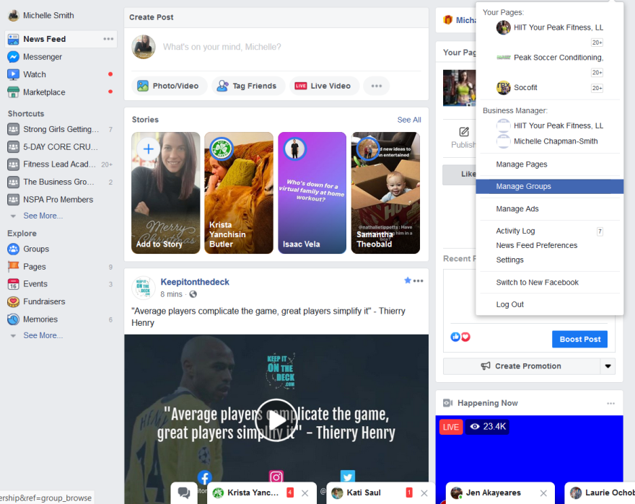
Click “Create Group” and follow the prompts. Use the Facebook Help function for more assistance
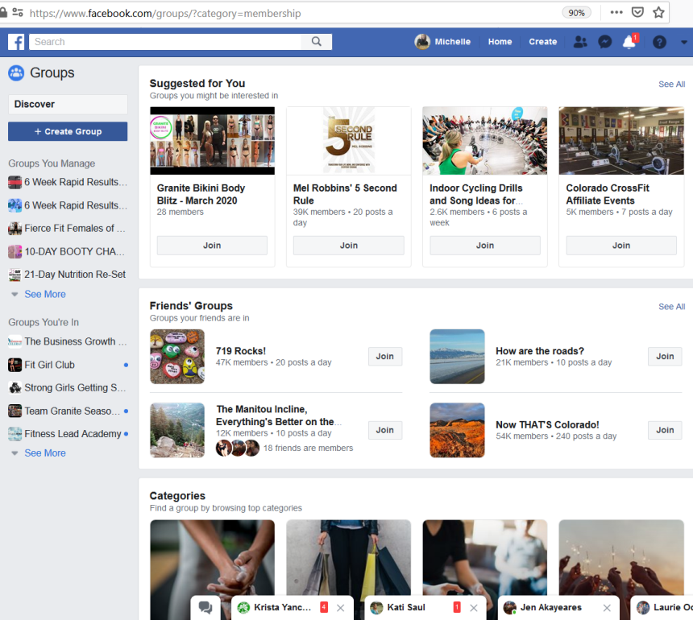
Once done, or if you already have a group set up, start a Live Video but don’t hit the “Go Live” button just yet
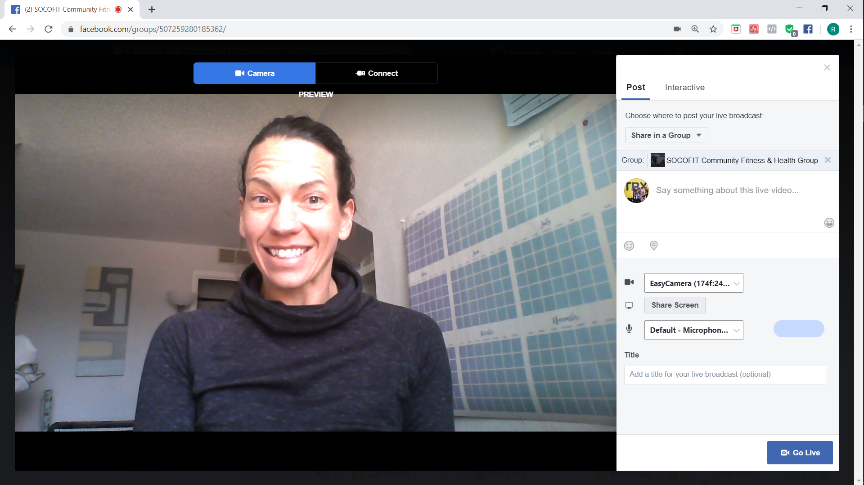
Go back to Zoom and Click: “Host a Meeting” and select “With Video On”
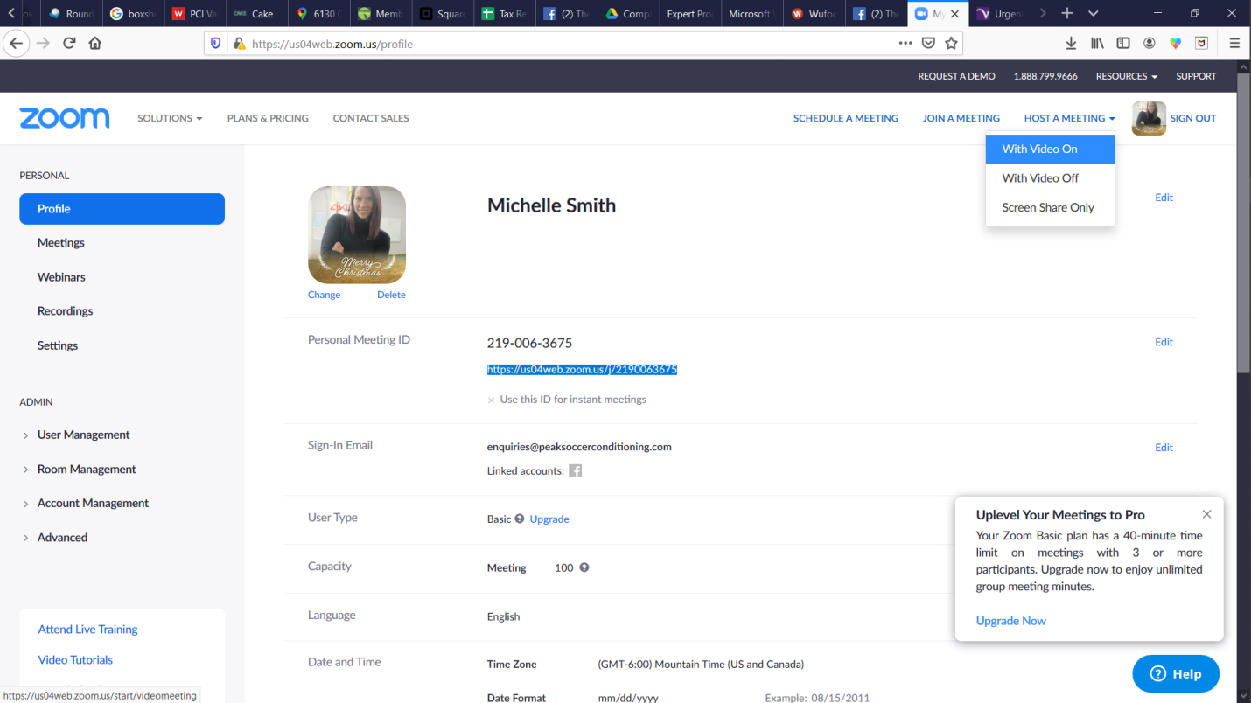

Once the task manager opens, click the button to open the link. On loading, make sure to click the video and unmute buttons in the bottom left to begin your recording. Now you can practice your livestream and play with camera positions.
Set up:
Wherever you are recording, you will need lots of light. The more natural, the better.
This is the view with a window in front of me (behind the camera)
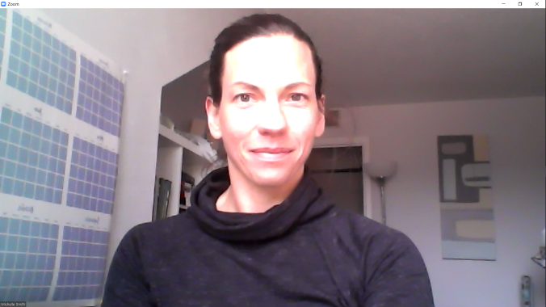

This is the view with a window behind me (in front of the camera)
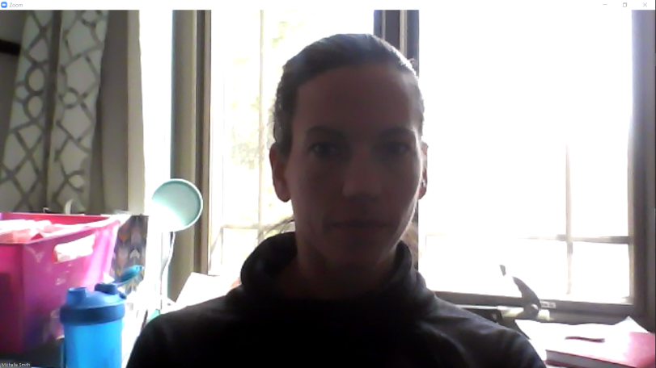
You can see the difference in lighting. You may need to add photography lighting such as this if your video is dark: photography lighting
If you are in your studio, you *should* be okay.
Camera height and distance from you:
In order for avoid messing with your camera during a live stream, you will need to set it up so that the camera is at least 7-8ft away from your position and at a height where you can angle the camera down slightly. That way, your feet up to your head can be seen. Be sure that if you are doing overhead movements that you stand further away so that your hands and equipment can be seen. When you are down on the ground, your whole body should still be visible.
If you are live streaming a class, rather than you teaching a workout, you will need to be angling your camera down at the participants from a height that allows your whole room or a section to be viewed. Everyone’s rooms are different so you will need to play with this. I have recorded from the corner of a room which gives a great side view and from front and center. If you are able to set up a second camera to get an additional view, you can splice the 2 videos together in editing (outsource that unless you have time and the skill set).
Audio:
I recommend a lav mic or headset for best quality but test it out. If you are in a big room with an echo, your participants may have trouble hearing you. When you are giving cues to your clients, be very descriptive as you coach, enough that if you were blind or had your eyes closed you would be able to perform the exercise well. Many people will watch and not listen or listen and not watch. Cover your bases.
Other tips:
Have your timer and your session plan ready. I pin my session plan next to my recording device so that it appears I’m still looking straight at the camera when I’m looking for the next exercise.
Sounds odd but be mindful of your dress choices. You will now be working out with them so good fitting sports bras and pants or shorts that don’t show your undies in the photography light or your intergluteal cleft ;-)

Practice time:
Start your recording in Zoom,
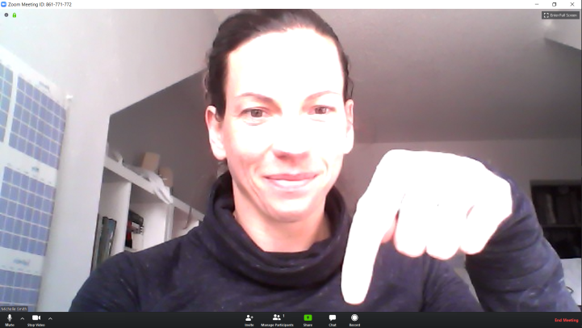
Open your Facebook page and click the “Share Screen” button
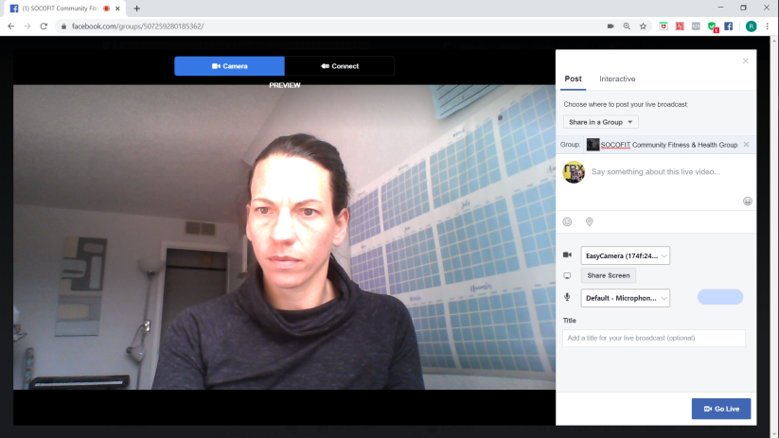

Click the “Application Window” tab, select “Zoom” and click “Share”
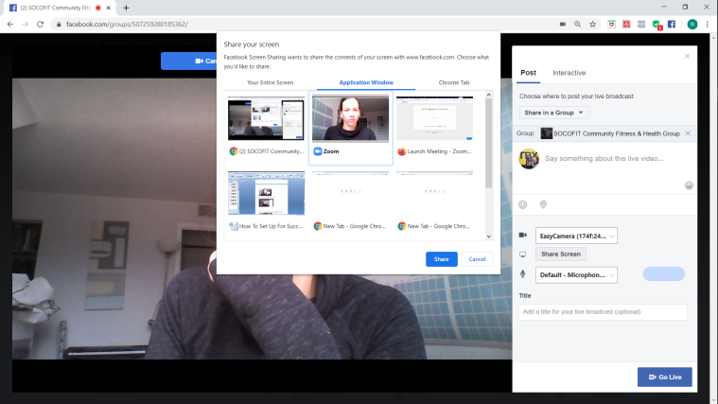
Click “Go Live” on the Facebook screen and begin your broadcast.
When you are done, click “Stop Sharing” and end your live Facebook video.
Once you have finished your recording, go to Zoom and click “End Meeting” and it will save to your hard drive.
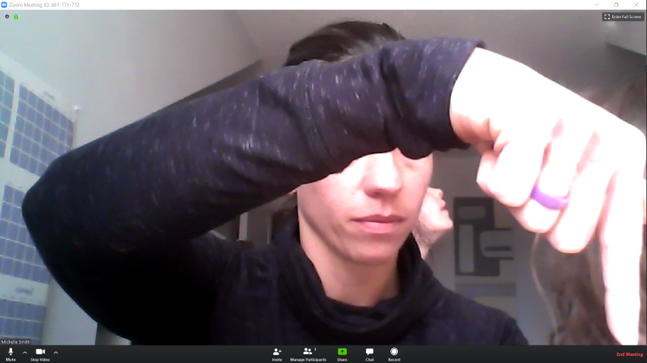
You can now locate your video file and upload to your membership site, Facebook Groups etc.

Setting up your schedule for Live Streaming
Click the “Schedule a meeting” button. Enter your date and time that you wish to run the zoom with your clients.
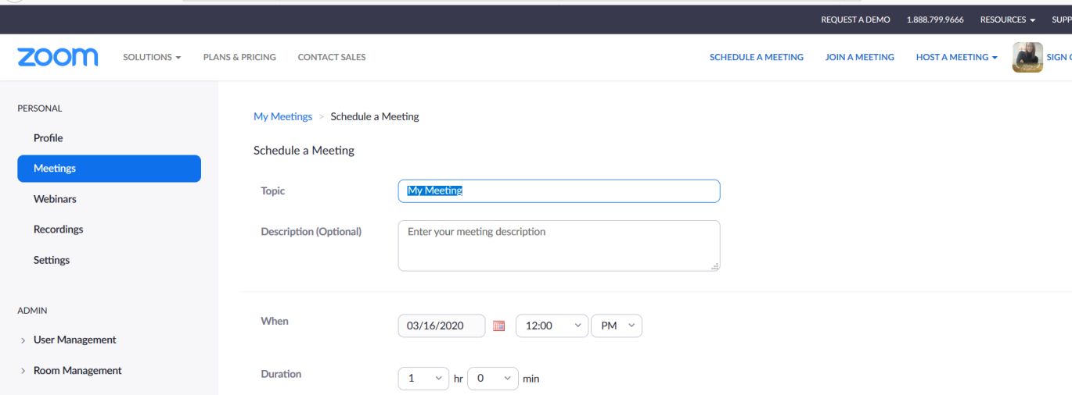

Scroll down to the settings. I highly recommend you use the ones shown below:
Video – on for host and participant
Audio both (although voice in capabilities have been restricted so people need to dial in with computer audio for good connection)
Meeting: Enable join before host, mute on entry, record automatically (don’t miss this one)
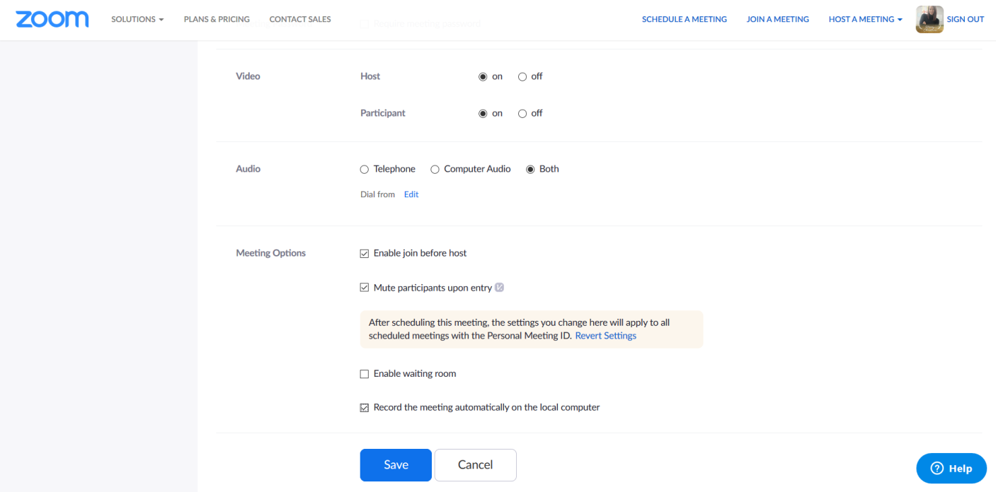
Once you save this, click here to copy the invitation to send to your clients using whatever method you choose
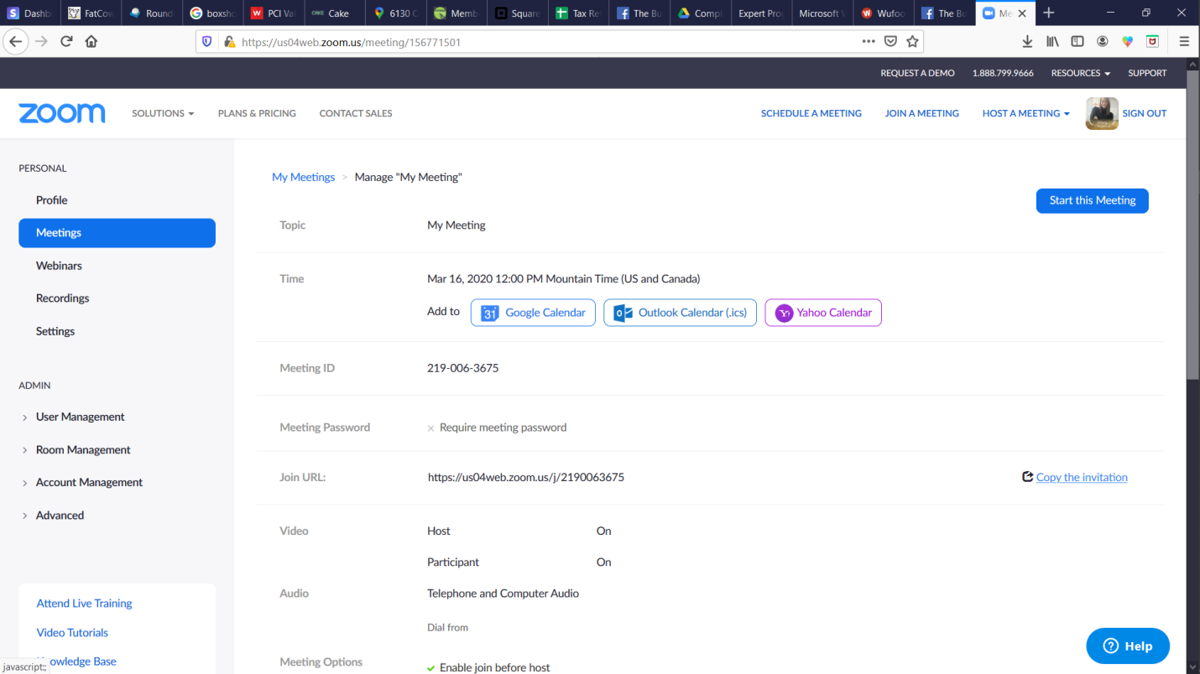

You can also live stream to your YouTube Channel!
Click here for more info: YouTube Livestream
I have not tried live streaming to 2 platforms from the same device. You can test it or simply use an additional device.
If you only have a cell phone or tablet, you can live stream from Facebook to a group and then download and edit your video to repurpose, but you will not be able to see your participants while you do this.
Nervous? I pretend that I’m coaching my twin sister. I even laugh at her bad jokes; takes the edge off.
I hope this is helpful. Tag me in the Facebook group if you have questions that I haven’t covered.
Michelle (Gold Bars) Smith
SOCOFIT
Colorado Springs

